HOW TO UPLOAD THE COVID-19 VACCINATION CARD to MAGNUS HEALTH

On the Mobile App:
- Click on Student Health Tracker

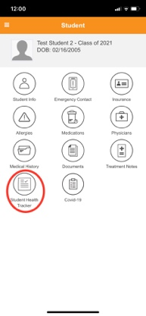

- Click on Immunization Requirement **Don’t click on “more details”
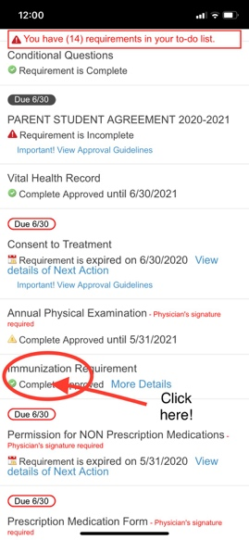

- Click on “Add Files” and hit “continue”
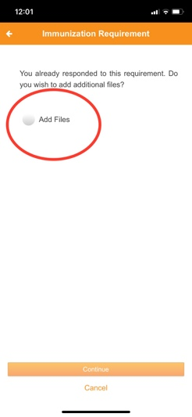

- Click on “Add File”
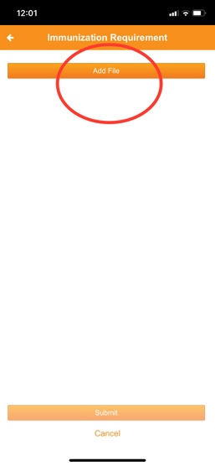

- Click on “ Take Photo”

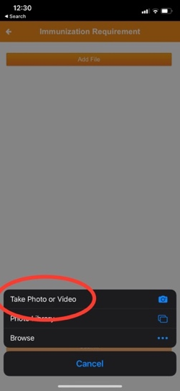

- Take picture of the card and click on “save photo”

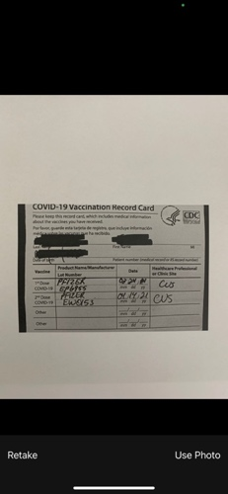

- Click on the button next to “image.jpg”, then click “submit”

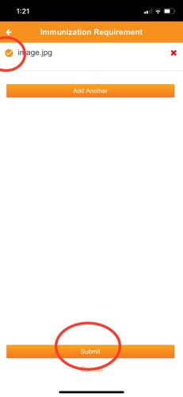

- You’re done!

